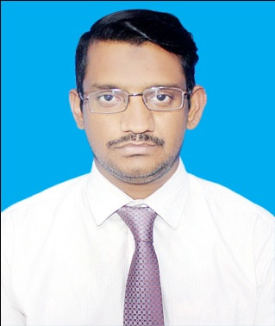

MALIK WAQAR AHMED

Personal Information
Father Name: Malik Muhammad Akbar
Date of Birth: 11-12-1984
Sex: Male
CNIC: 41303-7378930-7
Domicile: Urban
Email: vikigohar_2012@hotmail.com
Cell #: 0311-8866720
Status: Married
Address: House No 38, Block-F, Mir Nabi Bux Town, Paretabad, Hyderabad, Sindh, Pakistan

Objectives
As a bright ambitious person, I enjoy working in a fast paced, highly motivating position where I can assist others while challenging and expanding my knowledge and understanding of the task at hand. I am seeking a position that will utilize my skills and offer the chance for advancement as well as allow me the opportunity to gain additional skills and experience.
Experienced

Traders : Al Sakhi Lubricants Traders
Position : worked as accountant from 12-09-21 To Till dated
Builders : Harem Builders and Developers
Position : Worked as Manager from 01-03-21 To 31-08-21.
Company: Memon Motor Pvt Ltd (Assembler-cum-Manufacturer of super star Motor Cycle
And Auto rickshaw)
Position : Worked as Assistant Accountant from 12-02-14 to 30-09-20.
SCHOOL : Excellent grammar school:
Position : work as teacher from 2008 to 2012.
Company: Bonanza apparel
Position : work as computer operator in Karachi from 2006 to 2007.
Clinic : Culsoom charitable
Position : work as compounder from2001 to 2005.

Professional Qualification

M.COM IN FINANCE (University Of Sindh) 2014 CGPA 3.20
B.COM (University Of Sindh) 2010 SECOND DIVISION

COMPUTER SKILLS

- Short Courses (MS office, Adobe Photoshop, In page, Corel Draw, ERP Software)
- Experience of Computer Repairing
- Typing Speed 45 wpm

INTERPERSONAL SKILLS

- Proficiency in English
- Well communicate and Leadership GOOD Teamwork Member
- Easily become known to environment
- Target Achiever
- Hard worker

REFERENCESS:

will be furnished on request:

